Module 7 : Advanced Analytics in Tableau

1. Scatter Plot: Using the “Wind Mill.xls” data provided, create a Linear Regression Model for different locations data to predict the Wind Speed in different locations.

Sample Screen shot of Output:

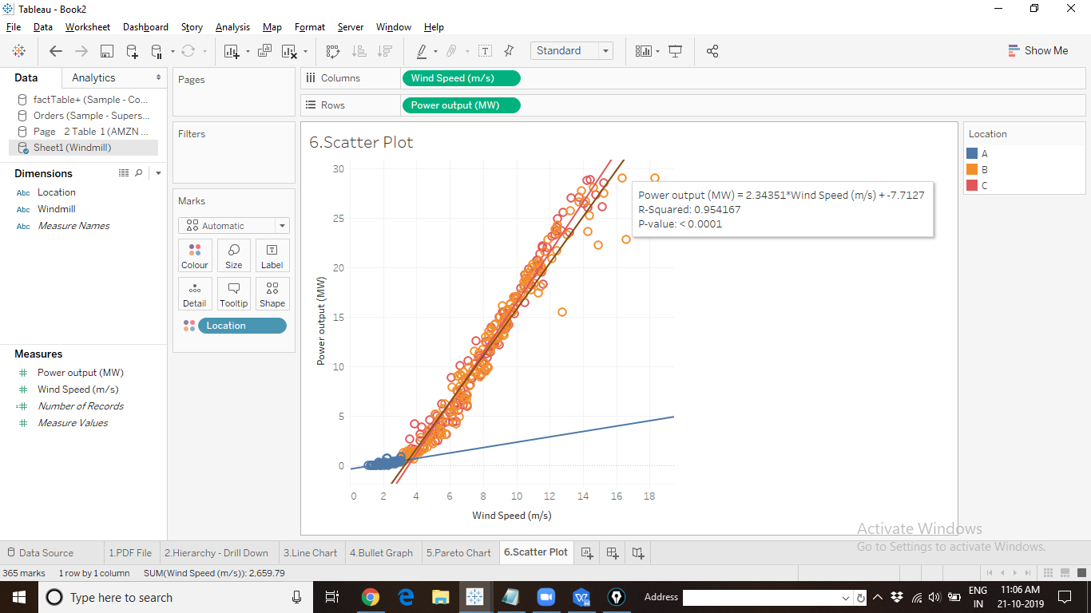

1. Histogram: Create the Frequency Distribution Plot to examine the GMAT scores. Explain your interpretation is the chart. Use mba.csv data source.

Sample Output Screen shot:

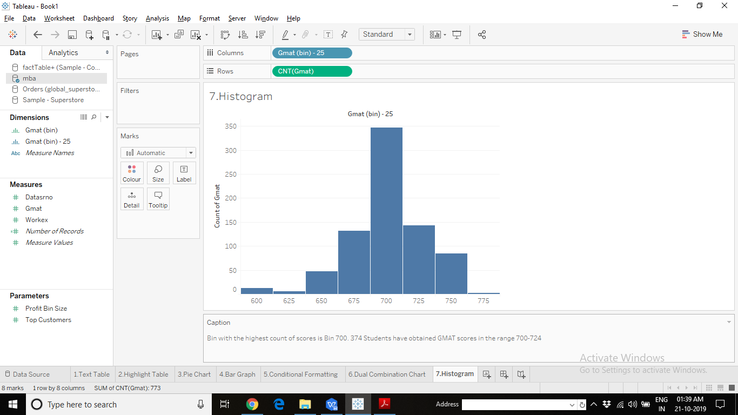

1. Forecasting: Use Global Superstore to create a visualization predicting the future trends of Sales over the next 6 Quarters for different Categories.

Sample Output Screen shot:

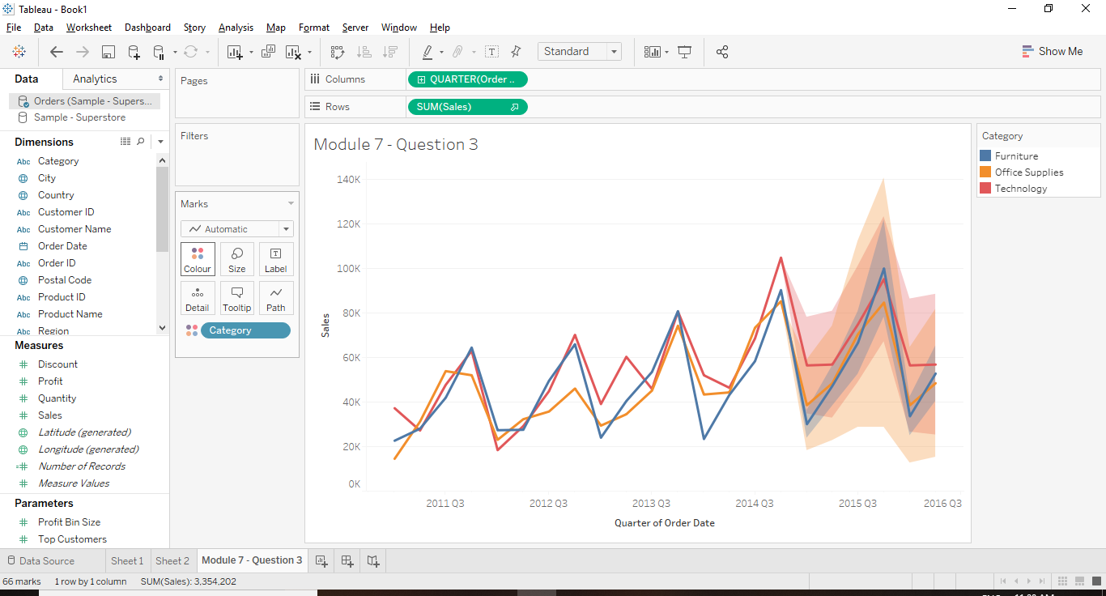

1. Clustering: Using Fisher’s Iris dataset given, create a scatter matrix. Create 3 clusters on each plot in the scatter matrix using the K-Means algorithm.

Sample Output Screen shot:

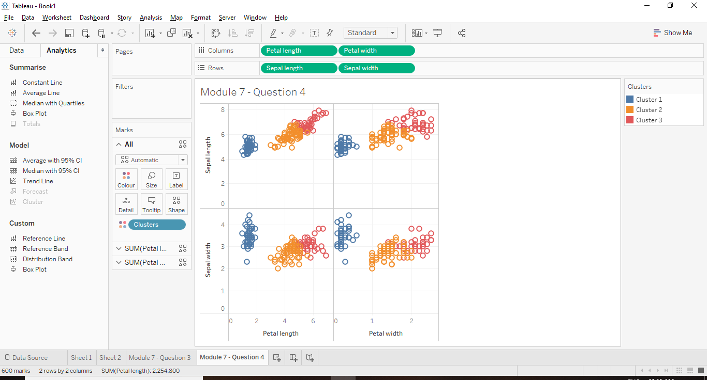

1. Trend Model: Express Profit as a function of Sales for different Order Id’s. What is the equation of the Linear Trend Model.

Sample Output Screen shot:

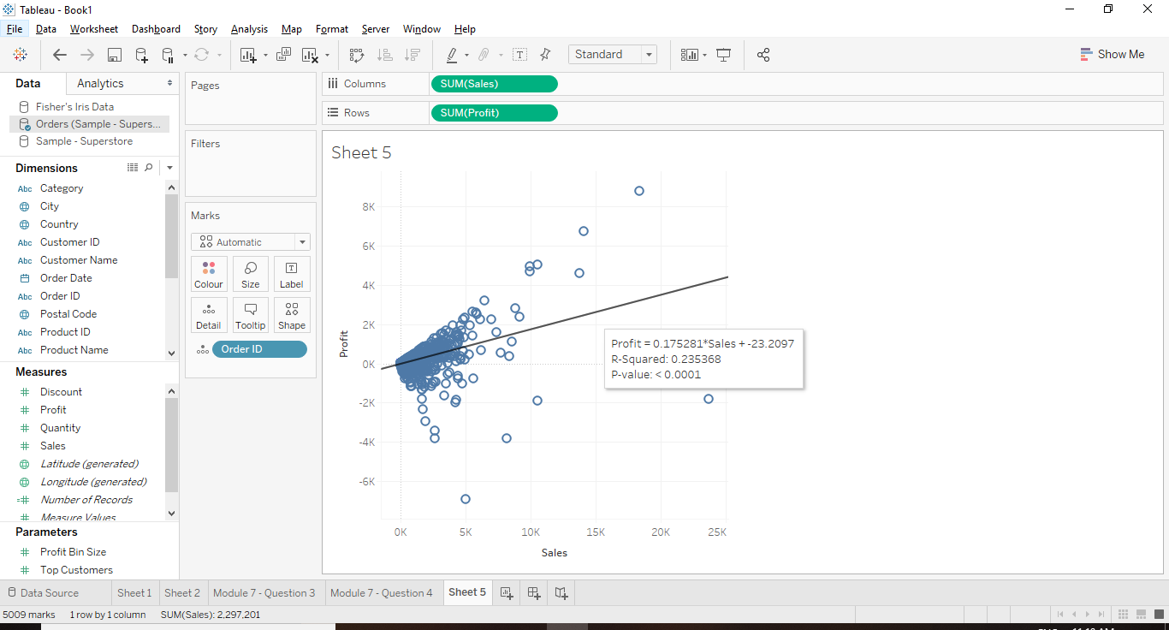

1. Parameters: Show the next level of detail in a hierarchy for just a selected attribute.

Hint: Create a String Parameter with the 3 different Category Names (Furniture, Office Supplies, Technology). Create a calculated field with Logical If Statement.

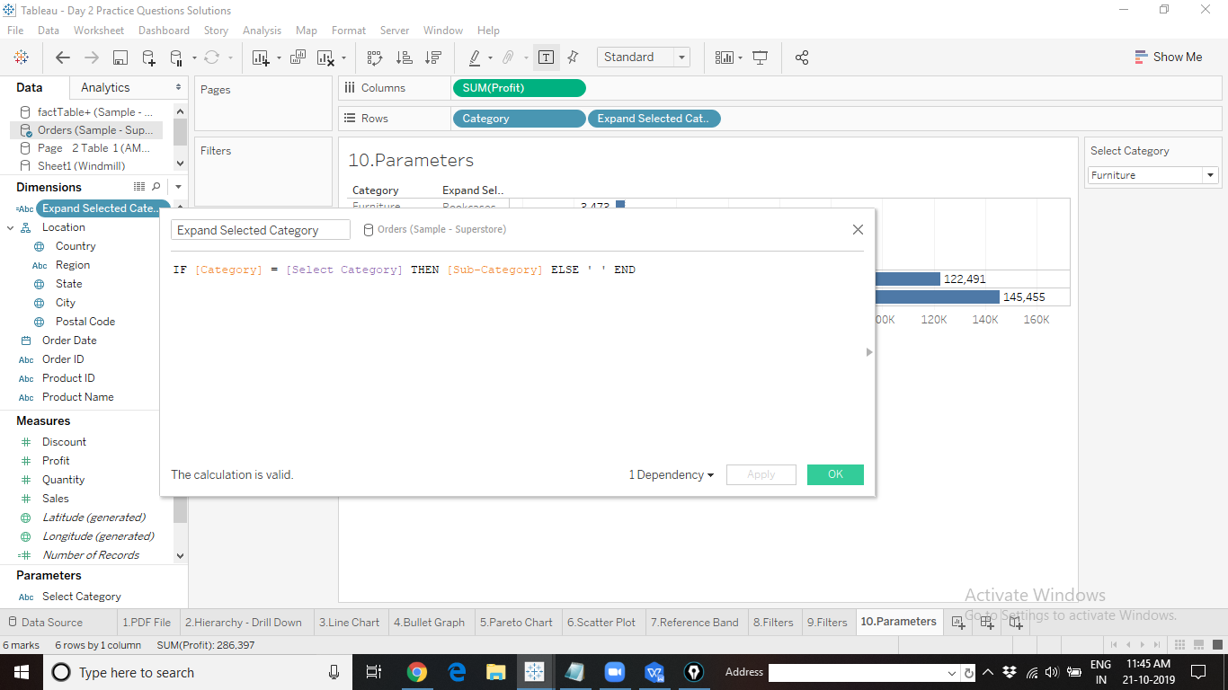

Sample Screen shot of Output:

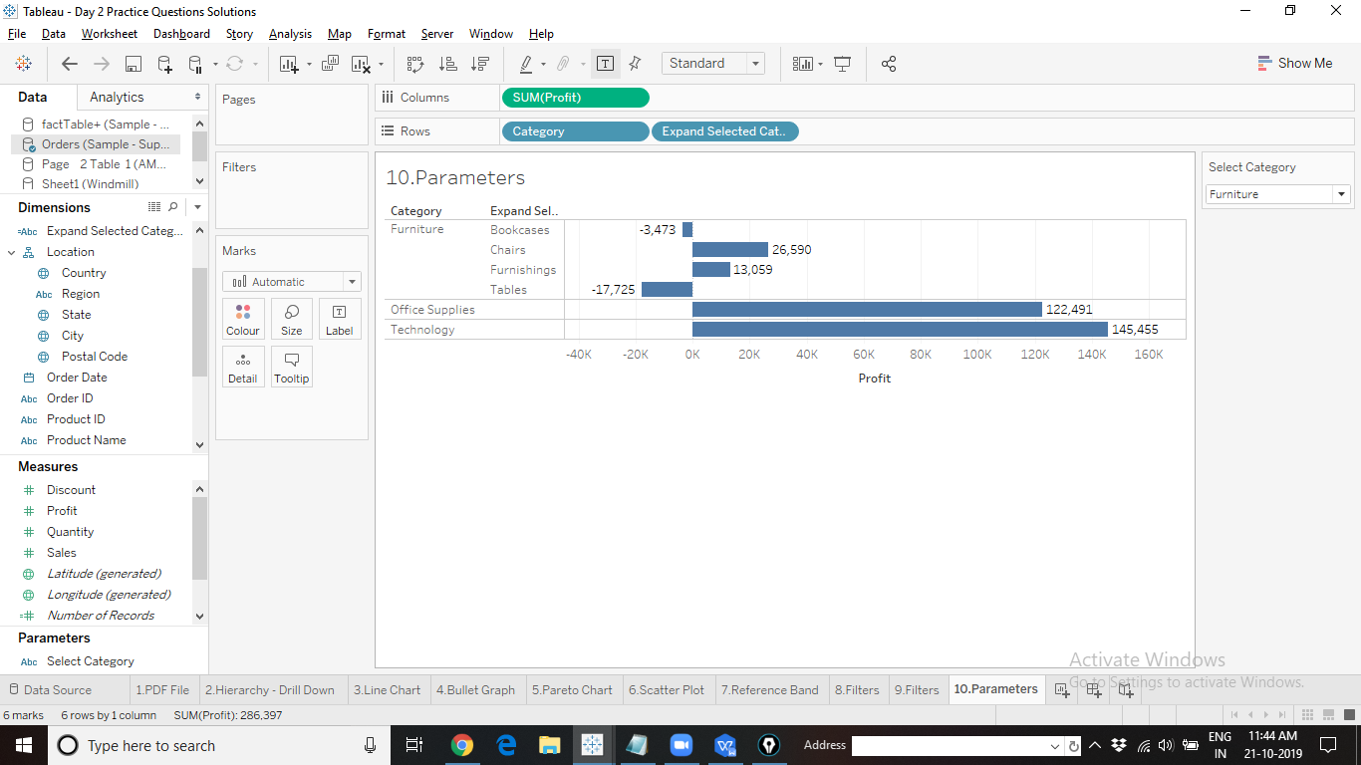

1. Parameters: Give the user the option to select which Dimension to be used in the view (represent data at selected dimension level).

Hint: Create a Parameter with the list of all the desired “Dimensions”

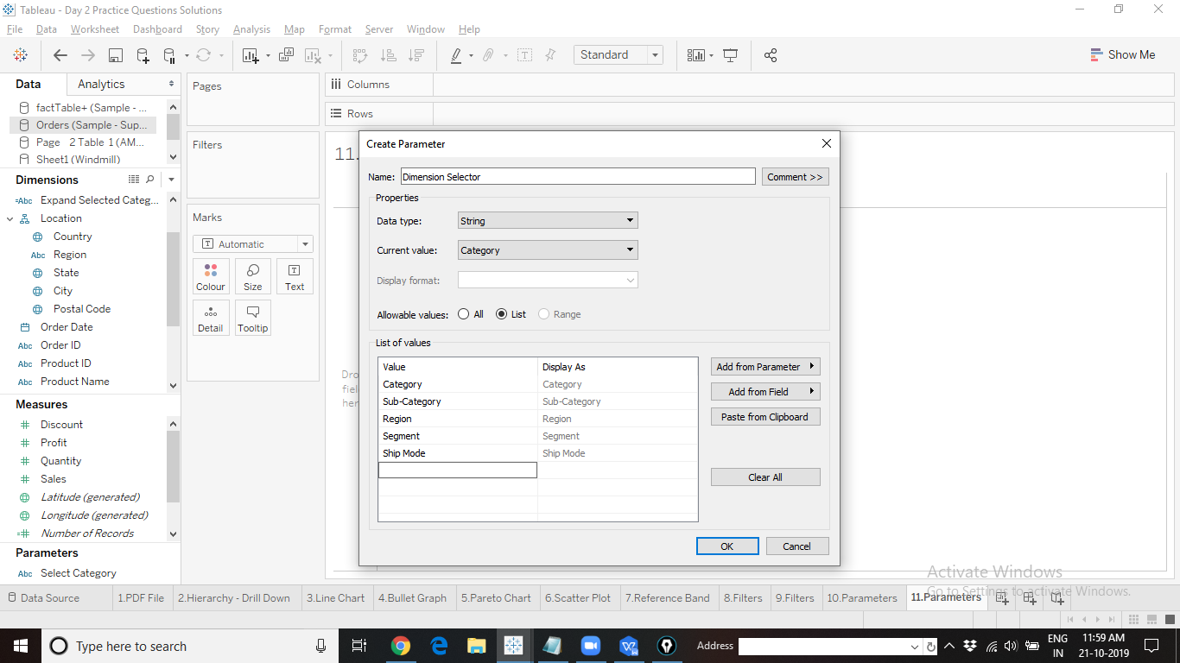

Create a Calculated field

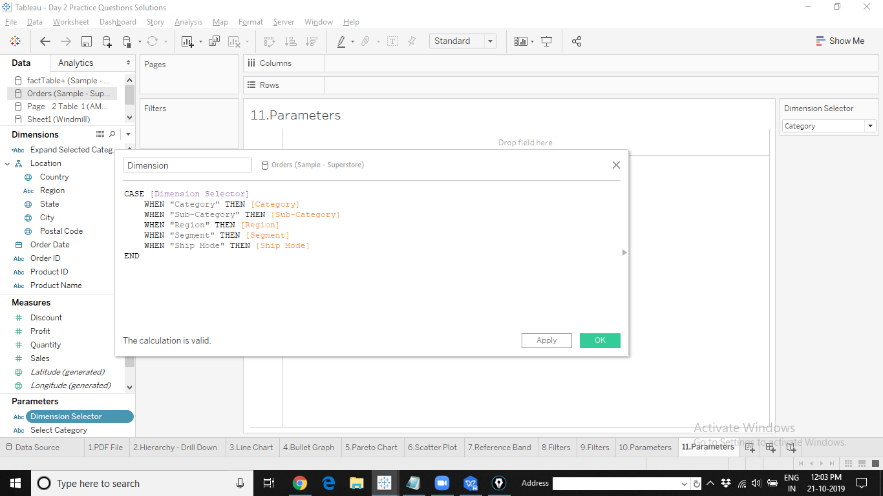

Sample Screen shot of Output:

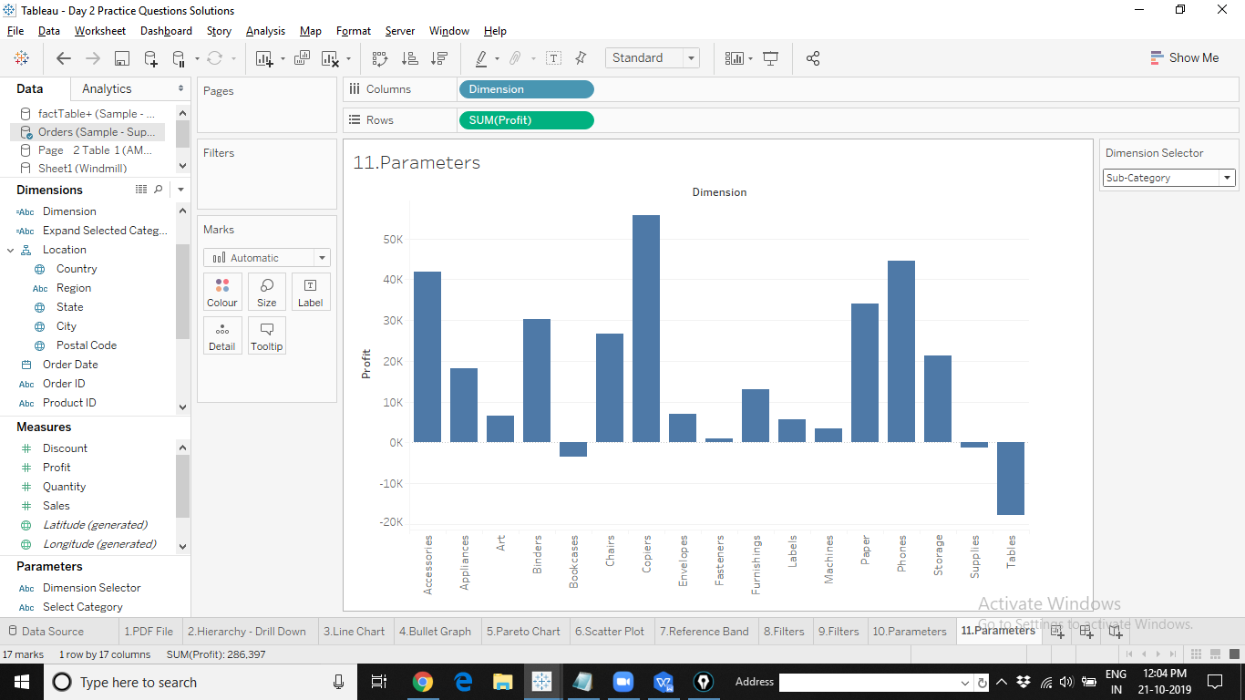

1. Parameters: Create a chart to display the Top N and Bottom N profitable Customers of Superstore in a single view.

Sample Screen shot of Output:

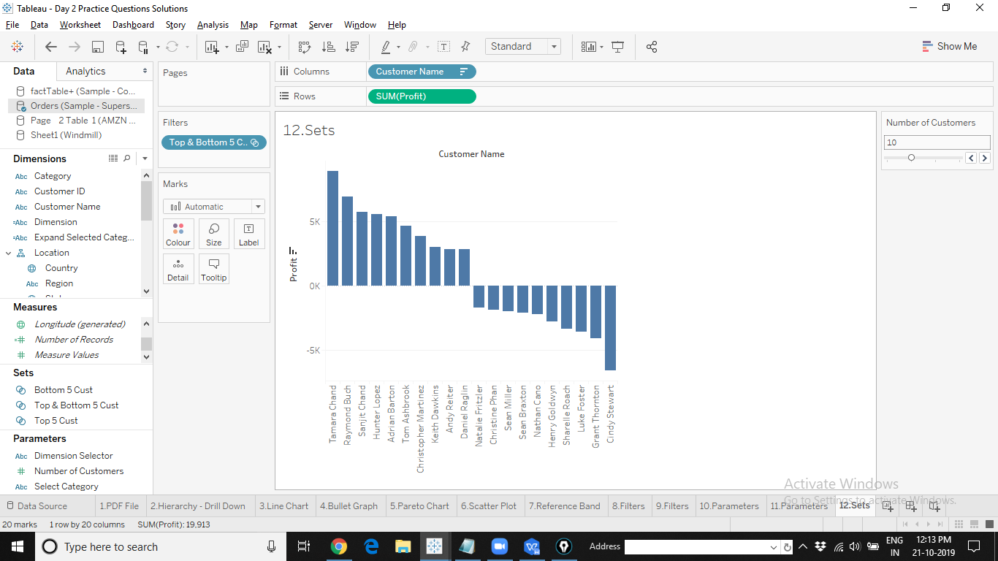

1. Parameters: Create a Parameter to retrieve a ‘Selection’s Average Sales’ value. Display the average on the worksheet title.

Hint: Use Parameter Action.

Create a Parameter for the requirement:

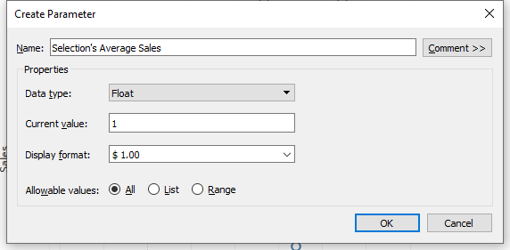

Set up the Parameter Action:

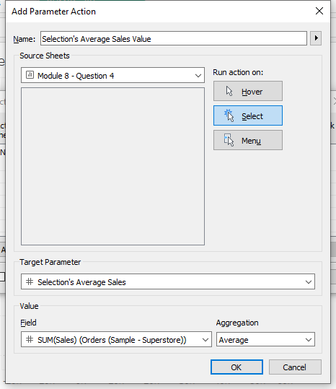

Edit the title to include the Parameter:

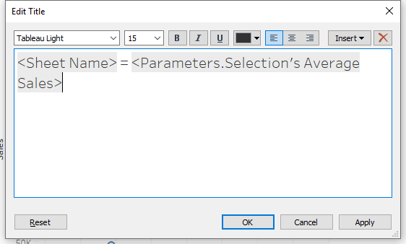

Sample Screen shot of Output:

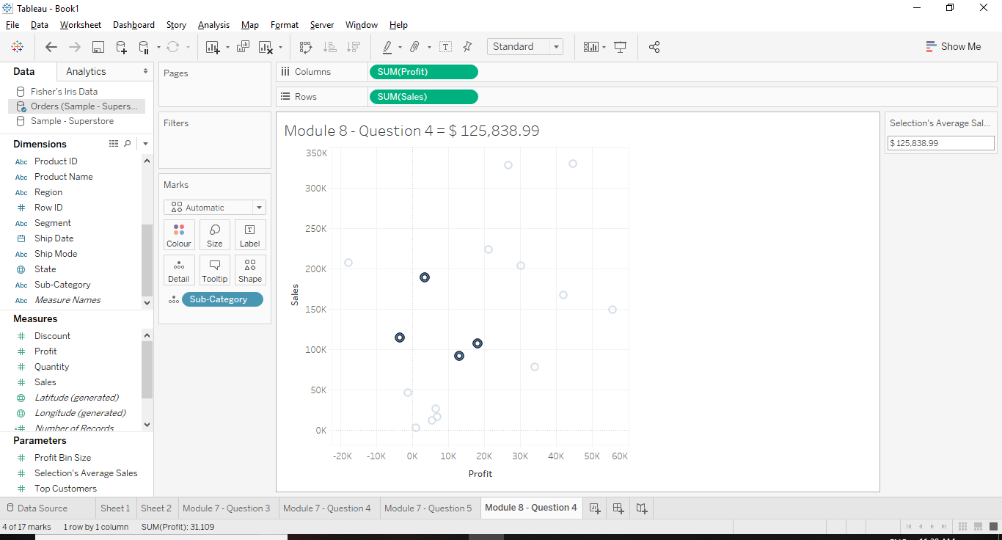

1. Parameters: For the above question, display the Selection’s Average Sales using a Reference Line.

Sample Screen shot of Output:

